**Level 1: PC Tower Case**

**Outline**

Learn about the internals of a standard PC case by examining physical samples and selecting and labeling images found on-line. Gain deeper knowledge by researching and reporting on specific components.

**Questions**

1. Find one (or more) images that clearly show the internals of a PC Tower Case.   
   (i.e. Google images using keywords “PC Case Internals”)

“Understanding Your Computer Hardware.” *Bask Technology*, www.bask.com/blog/understanding-your-computers-hardware. 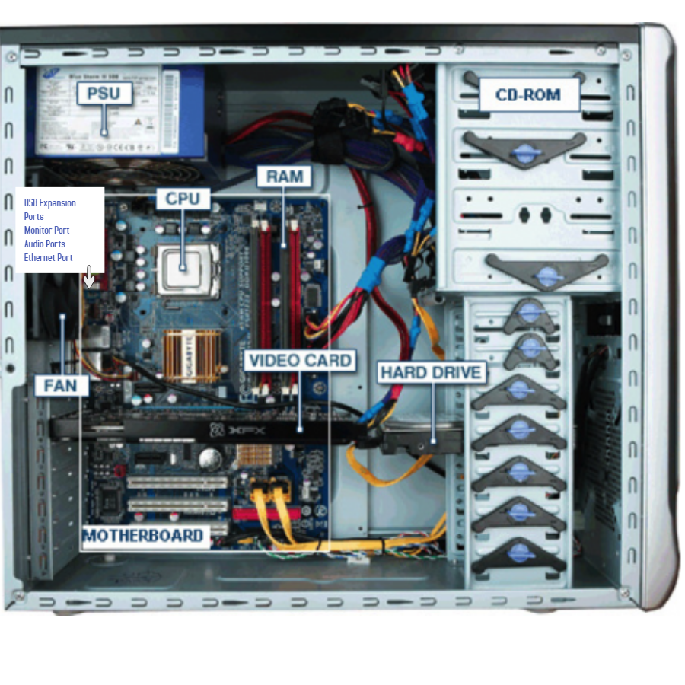

1. Clearly label the following components (using arrows) on your image of the PC case internals:
   1. Motherboard
   2. Power Supply
   3. Hard Disk Drive
   4. Optical Disk Drive (e.g.DVD)
   5. USB Expansion Ports
   6. Monitor Port
   7. Audio Ports
   8. Ethernet Port
   9. Cooling Fan
2. Research more in-depth about “Motherboards”. Make notes on the following:
   1. What different versions are currently available (speed and capacity)
   2. How the component has changed since the 1980’s
3. Different versions of the motherboard across the years since the 1980’s are:

* AT Motherboard
* ATX Motherboard
* LPX Motherboard
* BTX Motherboard
* Pico BTX Motherboard
* Mini ITX Motherboard

1. As motherboard technology advanced, computer technicians were able to reduce the size of the component and allow for interchangeability, as it could not before.
2. Research more in-depth about “Hard Disk Drives”. Make notes on the following:
   1. What different versions are currently available (speed and capacity)
   2. How the component has changed since the 1980’s
3. The different version of hard drives are:

* Parallel Advanced Technology Attachment (PATA)
* Serial ATA (SATA)
* Small Computer System Interface (SCSI)
* Solid State Drives (SSD)

1. As time passed, hard drives gained advancements in in terms of capacity, size, shape, internal structure, performance, interface, and modes of storing data.

**NOTE:**

* Download the on-line version of this module (from the class GitHub repository)
* Questions for Level 2 and Level 3 are in the on-line version of this module
* Provide your answers in a MS Word, PowerPoint, or equivalent format
* Upload your answers to your personal GitHub repository

**Level 2: PC Motherboard**

**Outline**

Learn about the structure of a standard PC motherboard by examining physical samples and selecting and labeling images found on-line. Gain deeper knowledge by researching and reporting on specific components.

**Questions**

1. Find one (or more) images that clearly show the layout of a PC Motherboard.   
   (i.e. Google images using keywords “PC Motherboard”)  
   “Parts of a Motherboard and Their Function.” *TurboFuture*, TurboFuture,

turbofuture.com/computers/the-motherboard-components.  
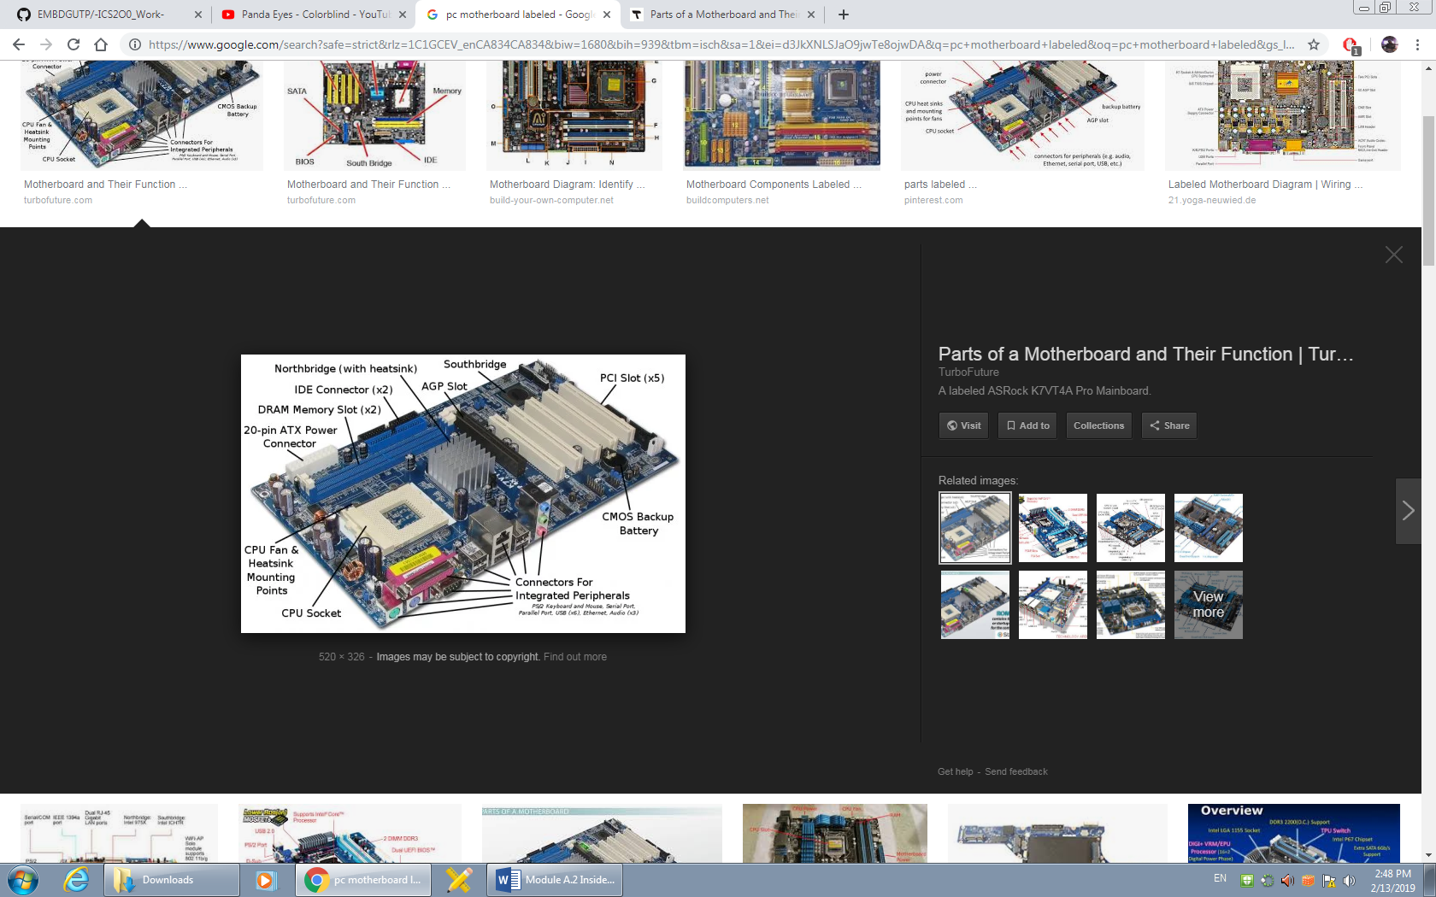

1. Clearly label the following components (using arrows) on your image of the PC motherboard:
   1. CPU (and fan)
   2. RAM Memory
   3. Disk Drive Interface (IDE or SATA)
   4. GPU Graphics Processor (either on-board or Graphics Card)
   5. Sound Processor (either on-board or Sound Card)
   6. Wi-Fi / Ethernet Network Interface (either on-board or Graphics Card)

1. Research more in-depth about “CPU Processor Chip”. Make notes on the following:
   1. What different versions are currently available (speed and capacity)
   2. How the component has changed since the 1980’s  
      a. There are two flagship cpu brands, Intel and Ryzen.

b. Over the years processers had advanced rapidly. The oldest processors couldn’t even reach mHz processing speed, while the more modern ones are in 3 - 4 gHz processing speed. For example, intel’s oldest processor the 4004 reach a max speed of 740 kHZ, while their newest one reaches a base speed of 3.6 gHz with a max of 5 gHz.

1. Research more in-depth about “RAM Memory”. Make notes on the following:
   1. What different versions are currently available (speed and capacity)
   2. How the component has changed since the 1980’s  
        
      a. The different versions of RAM Memory chips are SRAM, DRAM, SDRAM, SDRSDRAM, DDR1, DDR2, DDR 3, and DDR4.
   3. The RAM chips have been designed to hold more memory, as when DDR1 was introduced it could only hold up to 500 mb of memory, while DDR4 holds up to 64 gb per stick.

**Level 3: Peripheral Devices**

**Outline**

Learn about how peripheral devices are connected to the back side of a typical PC tower case. Examine physical samples, select and labeling images found on-line and gain deeper knowledge by researching and reporting on specific components.

**Questions**

1. Find one (or more) images that clearly show the layout of the back of a typical PC tower case.   
   (i.e. Google images using keywords “Back Of PC Tower”)  
   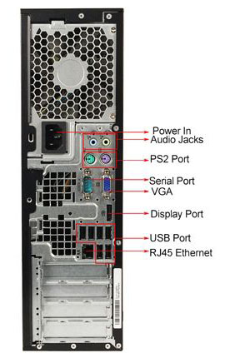

“Subjects.” *Peda.net*, peda.net/kenya/ass/subjects2/computer-studies/form-1/the-computer-system.

1. Clearly label the following components (using arrows) on your image of the back of a typical PC tower case:
   1. Power cord and power switch
   2. Monitor Interface (VGA or DVI or HDMI)
   3. Mouse Interface (USB or PS/2)
   4. Keyboard Interface (USB or PS/2)
   5. USB Ports
   6. Audio Inputs / Outputs
   7. Ethernet Interface

1. Research more in-depth about “Monitor Technology”. Make notes on the following:
   1. What different versions are currently available (e.g. VGA / DVI, Flat Panel Technology))
   2. How the component has changed since the 1980’s (e.g. Display Resolution, Technology)  
      a. The computer monitor available are CRTs, LCDs and the current version LEDs.

b. CRT monitors were big and bulky with low resolution, the newer LEDs are larder, thinner, and show a higher amount of fps with a higher resolution.

1. Research more in-depth about “External Portable Storage”. Make notes on the following:
   1. Floppy Disks: hardware device that reads data storage information
   2. CD-ROM / DVD / Recordable CD/DVD: A disc which hold data for computers to process and then generate information based off of the data.
   3. USB Memory Drives: A storage device which holds data to be used by computers.
   4. Compact Flash Memory: A small chip which holds data until the data is t be used again at a later time. The data usually includes media filed such as video game save files.
   5. Cloud Based Storage: A storage system which takes data and uploads it to the internet so it can be accessed later by the user again anywhere without needed a physical device to hold the data.

**Level 4: PC Component Presentation**

**Outline**

Explore the development and features of a specific PC hardware component through deeper research and investigation. Work in partners to create a short presentation. Deliver the presentation to the class.

Each group will research a unique PC hardware component . Your specific topic will be assigned from the list provided below.

**Presentation Structure**

1. Explain what the PC component does and how it fits together with other components to make up a fully functioning PC.
2. Explain how the PC component works. Provide a diagram (image) showing the main parts of the component.
3. Research the current state of the art of the component in terms speed, capacity (size), and other related factors.
4. Research on-line suppliers that sell the PC Component. List the specifications for the available products and the cost (price).
5. Research how the PC component has changed and evolved since the early days of PCs in the 1980’s. Cover each of the following topics separately:
   1. Component Speed
   2. Component Size / Capacity
   3. Two other specifications specific to the PC component (ask Mr. Nestor)

**PC Component Topics**

|  |  |  |
| --- | --- | --- |
| **Topic** | **Partner 1** | **Partner 2** |
| CPU Microprocessor Chip |  |  |
| Motherboard Layout |  |  |
| Computer Graphics |  |  |
| Sound & Audio |  |  |
| Hard Disk Drives |  |  |
| Removable Disk Storage |  |  |
| Network / Internet Connectivity |  |  |
| Mouse / Pointing Devices |  |  |
| Monitor & Display Technology |  |  |
| Printers & Output Technology |  |  |